How to place a “Service Order” or No-Charge Warranty Parts Order in AQ

- You can only place a Service Order if you have the orginal AQ Order Number. All orders will show a on your project tree

- Click on the icon at the top of your page

- In “Quote Number” Field, enter original AQ Order Number – Click Search

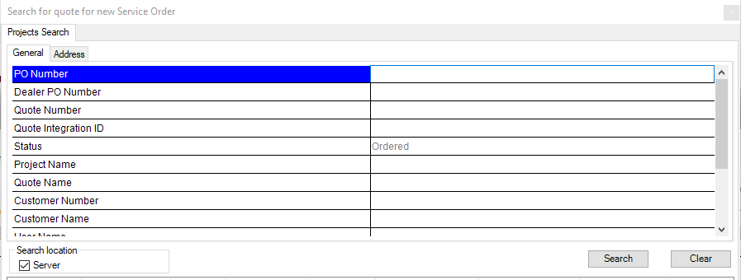

- Order will appears in Search Field Highlighted – Click Next
  - A ‘pop-up’ box may appear stating the system will find the MOST RECENT VERSION OF YOUR ORDER – CLICK YES

- Put “Quantity” in open field for each line item affected – Click Accept

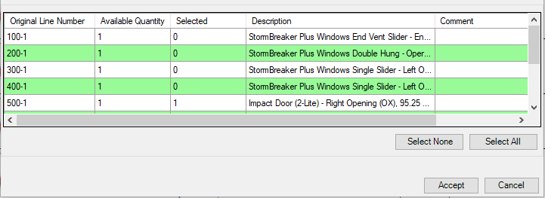
INSIDE QUOTE: Service line item should turn “GREEN”
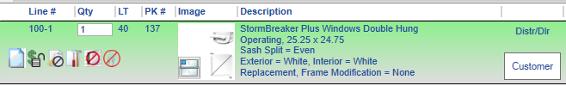
- Double-Click or Select Edit to each Line Item.

- Go to the Window Design Options and choose the Unit Type to select the part you need - i.e. Complete Unit, Frame, Sash (you will be asked to indicate top / bottom or left / right) Screen, etc.

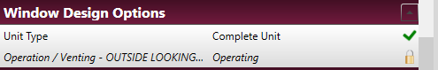
PRO TIP: IF YOU NEED TO SELECT TWO DIFFERENT COMPONENTS FOR ONE LINE, YOU WILL WANT TO EDIT THE LINE AND SELECT ONE OF YOUR TWO OPTIONS, I.E. TOP SASH, THEN SELECT FINISH & EXIT. IF YOU NEED THE BOTTOM SASH AS WELL, COPY THAT LINE, AND CHANGE THE COPIED LINE TO A BOTTOM SASH, THEN FINISH & EXIT.
- Pricing will show on Service Order. For a No Charge Remake follow the steps below. Simonton will adjust the pricing to no Charge.
  - Edit PO on the Customer Info Tab – Add R to the current PO #
  - Add Reasoning in Notes tab under Notes to Simonton so we can remove price.
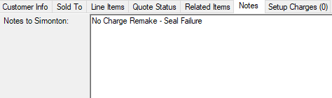

- To Submit, Click the Order Icon, then Click Accept on the Attribute Display Screen.

Re-Order should appear on Simonton Online within 24 hours.

